### it llogo2.JPG WATER QUALITY MONITORING USING REMOTE SENSING

*EPICS PROJECT REPORT*

*Submitted by*

**VISWANATH BODAPATI (208W1A1201)**

**SOTSAVA SKANDHAA BAJI (208W1A1202)**

**THARUN SAI PANUGANTI (208W1A1242)**

*Under the Guidance of*

**Dr. G. JAYA LAKSHMI**

**Assistant Professor**

*For the award of the degree*

**BACHELOR OF TECHNOLOGY**

**IN**

**INFORMATION TECHNOLOGY**



**DEPARTMENT OF INFORMATION TECHNOLOGY**

**V R SIDDHARTHA ENGINEERING COLLEGE**

**(AUTONOMOUS - AFFILIATED TO JNTU-K, KAKINADA)**

### Approved by AICTE &Accredited by NBA

**KANURU, VIJAYAWADA-7 ACADEMIC YEAR**

**(2022-23)**

# V.R. SIDDHARTHA ENGINEERING COLLEGE

(Affiliated to JNTUK: Kakinada, Approved by AICTE, Autonomous)  
 (An ISO certified and NBA accredited institution)

Kanuru, Vijayawada – 520007



## CERTIFICATE

This is to certify that this project report titled **“Water Quality Monitoring Using Remote Sensing”** is a Bonafede record of work done by **VISWANATH BODAPATI (208W1A1201), SOTSAVA SKANDHAA BAJI (208W1A1202), THARUN SAI PANUGANTI (208W1A1242)** under my guidance and supervision is submitted in partial fulfillment of the requirements for the award of the degree of Bachelor of Technology in Information Technology, **V.R. Siddhartha Engineering College** (Autonomous under JNTUK) during the year **2021-2022**.

#### Dr. G. Jaya Lakshmi Dr. M. Suneetha

Assistant Professor Professor & Head

Dept. of Information Technology Dept. of Information Technology

**TABLE OF CONTENTS**

**ACKNOWLEDGEMENT** iii

**LIST OF FIGURES** iv

**ABSTRACT** v

CHAPTER-1 Introduction 7

* 1. Origin of the Problem 7
  2. Basic definitions and Background 8
  3. Problem Statement with Objectives and Outcomes 10
  4. Real time Applications of Proposed work 11

CHAPTER-2 Review of Literature 12

2.1 Description of Existing Systems 12

2.3 Summary of Literature Review 16

CHAPTER-3 Proposed Method 17

* 1. Design Methodology 17
  2. System Architecture Diagram 18
  3. Description of Algorithms 19
  4. Description of datasets, Requirements and Tools 20

CHAPTER-4 Results and Observations 21

* 1. Stepwise description of Results 21
  2. Test case results/Result Analysis 22
  3. Observations from the work 23

CHAPTER-5 Conclusion and Future work 24

* 1. Conclusion 24
  2. Future study 25

**REFERENCES** 27

**FIELD WORK** 28

### ACKNOWLEDGEMENT

First and foremost, I sincerely salute our esteemed institution **V.R SIDDHARTHA ENGINEERING COLLEGE** for giving me this opportunity for fulfilling my project. I am grateful to our principal **Dr. A.V.RATNA PRASAD**, for his encouragement and support all through the way of my project.

On the submission of this Project report, I would like to extend my honor to **Dr. M. Suneetha**, Head of the Department, IT for her constant motivation and support during my work.

I feel glad to express my deep sense of gratefulness to my project guide **Dr. G. Jaya Lakshmi, Assistant Professor** for her guidance and assistance in completing this project successfully.

I would also like to convey my sincere indebtedness to all faculty members, including supporting staff of the Department, friends and family members who bestowed their great effort and guidance at appropriate times without which it would have been very difficult on my part to finish the project work.

### LIST OF FIGURES

**Figure Page**

Figure 1.1: ARIMA Model Structure vii

Figure 1.2: Image Processing Techniques viii

Figure 1.3: Semi-Automation Plugin viii

Figure 3.1: Giovanni xvi

Figure 3.2: System Architecture Diagram xvii

Figure 3.3: Dataset Description xix

Figure 4.1: Prediction Results using ARIMA model xx

Figure 4.2: Time Averaged Map of Chlorophyll a Concentration xxi

Figure 4.3: Time Series, Area Averaged of Chlorophyll [MODIS-Aqua] xxi

Figure 4.4: Chlorophyll Concentration and Sea Surface Temperature xxi

Figure 4.5: Training and Validation Accuracy xxii

Figure 4.6: Training and Validation Loss xxii

Figure 4.7: Accuracy with ARIMA xxii

Figure 4.8: Skavith Aqua Website xxiv

### ABSTRACT

Water quality characteristics can be monitored using remote sensing techniques. Geographic information systems use remote sensing photos as well as the results of imaging analysis as major data sources like GIS and LANDSAT-8. Remote sensing enables the simultaneous viewing and mapping of vast areas of the earth's surface when used in conjunction with field surveys.

The use of remote sensing for weather forecasting is common in India. Additionally, it is employed to warn people of impending cyclones. It can be used to investigate issues like eutrophication of large bodies of water, oil spills from oil tankers, desertification, air pollution, land degradation, and deforestation. Our issue is the study of water quality using landsat-8 pictures. Artificial intelligence (AI) approaches such as MLP, SVM, and group method of data management were previously used to forecast the components of water quality.

A csv file with the data was selected. The best accuracy was connected to the RBD as the kernel function, according to a review of the SVM's structure. The outcomes showed that its precision is sufficient for practical uses. The ARIMA model had the lowest level of accuracy. Our proposed system uses artificial neural networks, such as the Recurrent Neural Network and ARIMA, to determine the water quality in coastal areas utilizing remote sensing data. To achieve a successful result, we select the algorithms that have multilayer perceptron’s. Additionally, utilizing web technologies and frameworks, we create a website that will provide weekly updates on the water quality in a specific location.

The individuals who live close to those water bodies would become more conscious as a result. The areas that will profit from this project are those that are close to water bodies, and those who live there will also be made aware of the problem of water contamination.

**Keywords**: Remote Sensing, Satellite Image Classification, Autoregressive Integrated   
 Moving Average Model

#### CHAPTER -1

**Introduction**

It provides an overview of the project's goal, inception, and applications. It also outlines the project's requirement and scope, as well as showing project stoppers, which detail where the project is appropriate.

#### Origin of the problem

Water quality characteristics can be monitored using remote sensing techniques. Geographic information systems use remote sensing photos as well as the results of imaging analysis as major data sources like GIS and LANDSAT-8. Remote sensing enables the simultaneous viewing and mapping of vast areas of the earth's surface when used in conjunction with field surveys. The use of remote sensing for weather forecasting is common in India. Additionally, it is employed to warn people of impending cyclones. It can be used to investigate issues like eutrophication of large bodies of water, oil spills from oil tankers, desertification, air pollution, land degradation, and deforestation. Artificial intelligence (AI) approaches such as MLP, SVM, and group method of data management were previously used to forecast the components of water quality (ARIMA). The basic idea of water quality remote-sensing is to first gather information using the empirical water quality monitoring data and corresponding remote-sensing image data and then obtain the water quality distribution in a longer time or wider space according to the model.

#### Basic Definitions and Background

* + 1. **ARIMA:**

Within Deep Learning, one of the most simple and effective machine learning algorithms for time series forecasting is ARIMA. This is the result of combining Auto Regression and Moving Average. An ARIMA model is essentially an ARMA model that has been fitted to a d-th order differenced time series in such a way that the final differenced time series is stationary. A stationary time series has statistical properties such as mean, variance, autocorrelation, and so on that remain constant over time.

The reason for splitting the dataset is that the model needs to be tested with some labelled data to see how close the predictions are to the real data. It is made up of three distinct parts. The autoregressive regression of the time series onto himself, the Integrated (I) component, is used to correct the data's non-stationarity. The final component, Moving Average (MA), models errors based on previous errors. AR(p), I(d), and MA are assigned to each component separately (q). We need the Autocorrelation Function (ACF) and the Partial Autocorrelation Function (PACF) to estimate the value of each parameter (PACF)

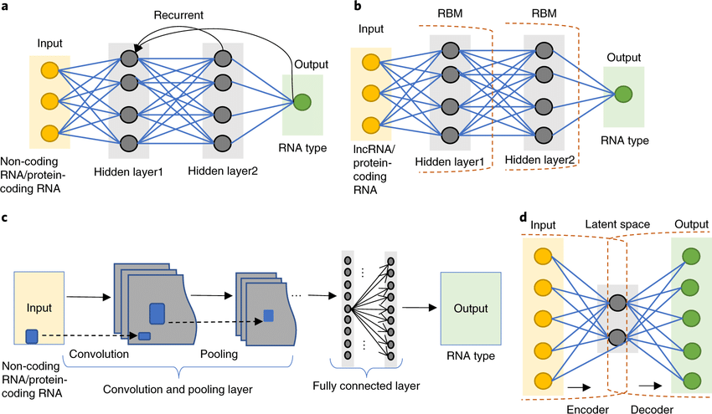

Figure 1.1: ARIMA Model Structure

#### Satellite Image Processing:

The Semi-Automatic Classification Plugin (SCP), which offers tools for image download, preprocessing, and postprocessing, enables the supervised classification of remote sensing images.

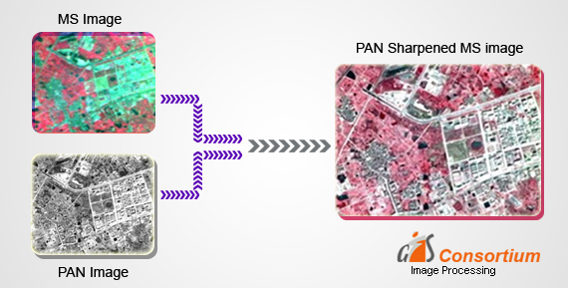

Figure 1.2: Image Processing Techniques

#### Semi Automation Plugin (QGIS):

The act of classifying objects into categories is known as classification. Multiple classes are predicted in this type of classification. Neural units are grouped into layers in neural networks. The input is processed, and an output is produced in the first layer.

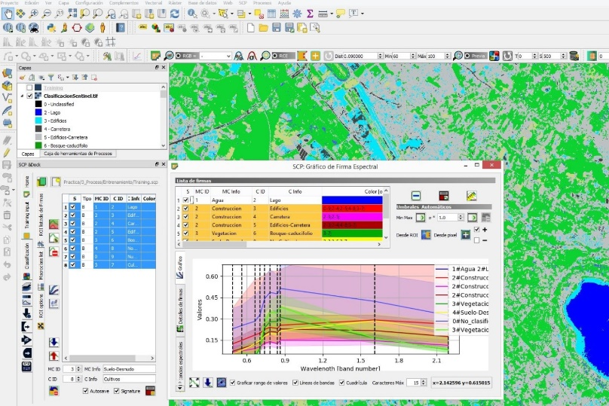

Figure 1.3: Semi Automation Plugin

#### Problem Statement with Objectives and Outcomes

* + 1. **Problem Statement:**

The fundamental concept behind water quality remote sensing is to first acquire data using empirical water quality monitoring data and associated remote-sensing image data, and then obtain the distribution of water quality over a longer period of time or a greater area in accordance with the model.

#### Objectives:

Early This project's primary goal is to interpret satellite imagery for monitoring and evaluating water quality:

* Access the Landsat and MODIS data
* Process images made from MODIS and Landsat data.
* Keep an eye on the water's temperature and chlorophyll levels for signs of dangerous algal blooms

By utilizing the visible, reflected infrared, and occasionally thermal infrared bands of the electromagnetic spectrum, satellite images have been successfully used to determine a variety of water quality parameters, including total suspended solids, turbidity, chlorophyll content, color, and temperature.

#### Outcomes:

Satellite images with atmospheric correction and on-site measurements. Estimates of chlorophyll-a from reflectance ratio graphs. Water Surface Temperature and Chlorophyll a Concentration (Chlor a) maps. Visualization of Sentinel-3 OCL-Based Chlorophyll Concentration. Bands from Landsat, MSI, OLCI, and MODIS, as well as VIIRS Bands Important for HAB Monitoring. Remote sensing imagery was processed to calculate Chlorophyll Concentration (Ch) and Sea Surface Temperatures (SST)

#### Real-time Applications of Proposed work

1. All facets of life, including people, animals, and the environment, are impacted by polluted water. Decision-makers can benefit from the near-real-time water quality data provided by satellite observations, which is publicly available. Applications of satellite data include controlling fisheries, public health, and drinking water supplies.
2. The mapping of active flood plains, long-range weather forecasting, estimating agricultural acreage and crop output, and creating "irritability maps" through land use planning are examples of typical applications.
3. Through the measurement of changes in water quality and the detection of dangerous algal blooms, remote sensing water monitoring aids in the evaluation of environmental issues and associated health threats.
4. The sustainable management of water resources, including runoff and hydrological modeling, flood management, watershed management, drought management, and management of irrigation command areas, has made use of remote sensing techniques.
5. Hydrological and Runoff Modeling
6. Flood Control
7. Watershed Administration
8. Drought Control
9. Management of the Irrigation Command Area

#### CHAPTER-2

**Review of Literature**

This literature review primarily focuses on the materials that assisted us in grasping an ideology of the image processing and remote sensing techniques research field. The research articles described in depth how various algorithms and frameworks might be used to classify data.

#### Description of Existing Systems

This section primarily focuses on research publications, covering the paper's primary details. It contains the findings and conclusions from each study**.**

#### Phytoplankton bloom status: Chlorophyll a biomass as an indicator of water quality condition in the southern estuaries of Florida, USA [1]

**Authors:** David T. Rudnick, Peter B. Ortner, Christopher R. Kelble, and Joseph N. Boyera

#### Year of publishing: 2020

**Observations:**

Florida Bay's circulation, salinity, and water quality patterns have changed as a result of altered freshwater inflows, which has also changed the estuary's structure and function. A situation where sediments and nutrients have been regularly disturbed, frequently resulting in large and dense phytoplankton blooms, has developed in Florida Bay as a result of changes in water quality and salinity and the resulting loss of dense turtle grass and other submerged aquatic vegetation (SAV). These cyanobacterial and algal blooms exacerbate the circumstances that are creating the blooms by frequently leading to further loss of freshly established SAV. Chlorophyll a (CHLA) was chosen as a water quality indicator because its concentrations reflect the combined effect of numerous water quality variables that restoration actions may change. It is an indicator of Phyto-plankton biomass. Overall, we determined that the CHLA indicator is (1) pertinent and accurately reflects the condition of the Florida Bay ecosystem, (2) responsive to ecosystem factors (stressors, particularly nitrogen loading), (3) practicable to monitor, and (4) supported by science. Statistics and general knowledge were used to define various zones inside the bay.

#### Conclusion:

The phytoplankton bloom indicator can be expressed in Report Card format as one double-sided page, just like the other Restoration Indicators (Fig. 4). The primary findings for this indication from the most recent assessment are shown on the top page, along with suggestions for maintaining or moving the Phyto-plankton bloom indicator into the "green." The phytoplankton bloom indicator's present, past, and projected future status in each of the ten sub-regions are listed on the back page along with a brief summary outlining the ecological justification for status assignment in each sub-region. The current criteria demonstrated their ability to identify changes from the reference condition for 2006, and they highlighted deviations that were at least partially brought on by anthropogenic activity.

* + 1. **Integration of passive and active microwave remote sensing to estimate water quality parameters** [2] **Authors:** Muntadher A. Shareef; Ali Khenchaf; Abdelmalek **Year of publishing:** 2019

#### Observations:

The estimation of the Water Quality Parameters (WQPs), including salinity, electrical conductivity (EC), and total dissolved salt, has been done using a new method (TDS). The thermal and SAR images from satellites serve as both an active input and a passive output for this approach, respectively. The Elfouhaily spectrum has been utilized as a physical model to compute the electromagnetic scattering by the river surface using the Small Perturbation Method (SPM). Basically, this technique is employed in the inversion process to identify the physical characteristics of water. Three steps make up the inversion process: In the first step, reflectivity coefficients are estimated using SAR images; in the second step, the water dielectric constant is determined using the polarization coefficient (in VV or HH polarizations);

#### Conclusion:

We can observe that calculating the electrical conductivity (EC), which is directly derived from the salinity value, yields an estimate of total dissolved salts (TDS). The comparison between the WQP estimated using the suggested method and those derived from in situ data is achieved to validate our methodology. A dataset of in situ data is used in this process. The results obtained demonstrate that the use of thermal images assists in estimating salinity ranges near to in situ, which improves the produced TDS. The outcomes also demonstrate that the thermal-TSX is beneficial in improving WQP mapping and estimation for application in the research area.

* + 1. **Water Quality Analysis of Remote Sensing Images Based on Inversion Model** [3]

**Authors:** Jinzhe Wang; Junping Zhang; Tong Li; Xiao Wang B **Year of publishing:** 2018

#### Observations:

In this publication, Water quality can be determined by spectral reflectance since the spectrum of water is closely related to the composition of the water. This study establishes the inversion model of water quality parameters for remote sensing images and analyses the state of water pollution using this model as a foundation. First, data from remote sensing photos is used to extract the spectral characteristics of the water in the study area. Then, a model is developed to show how spectral reflectance and water quality factors relate. SSE (Sum of Squared Errors), R-square, RMSE (Root Mean Squared Errors), and Adjusted R-square are used to evaluate the model. Inversion models are deemed to have been properly constructed when the R-square, Adjusted R-square, and SSE and RMSE are all close to 1.

#### Conclusion:

The trials were carried out on 14 Landsat 8 OLI pictures over the last four years, and the outcomes demonstrate that the model method is capable of achieving the analysis and monitoring of water quality. The dissolved oxygen's and permanganate's R-squares were 0.96 and 0.80, respectively, which met the application's requirements.

#### Summary of Literature Study

We have determined in this chapter that deep learning algorithms outperform machine learning techniques. In addition, the frameworks used are sophisticated, thus training a model takes longer. This research concluded that a methodology that takes less time to teach and a framework that is less hard to develop is required. We discovered that the methods previously proposed require more time to train a model. The complex frameworks also made model construction more difficult.

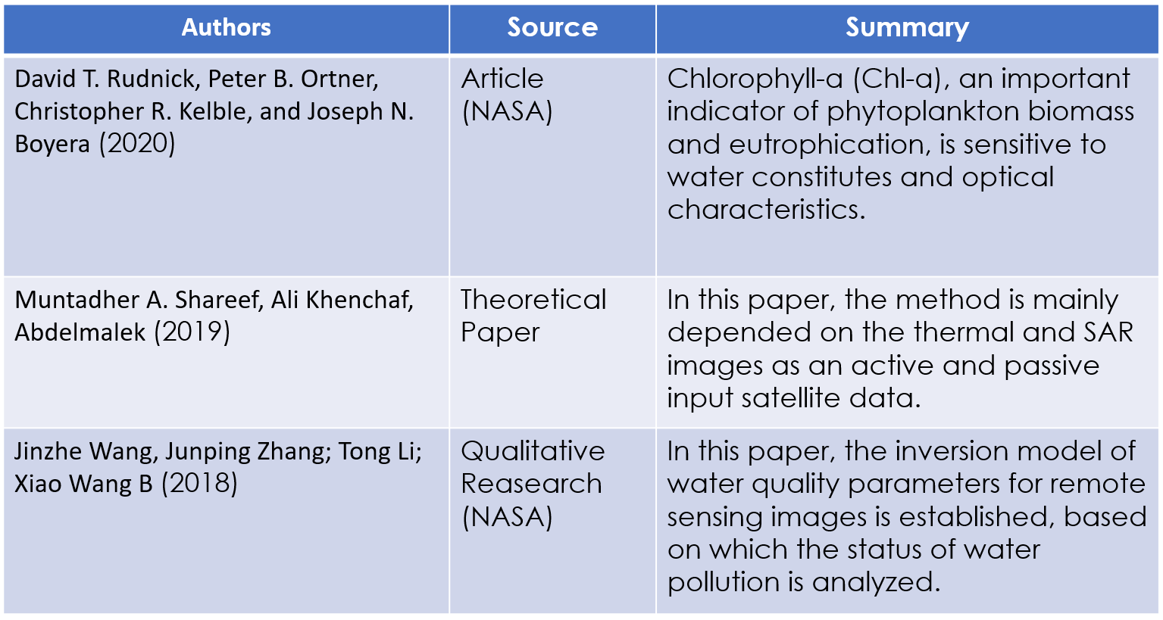

#### CHAPTER-3

**Proposed Method**

This chapter focuses on a procedure for identifying Water Bodies toxicity that produces excellent results.

#### Design Methodology

Numerous researchers have made extensive use of satellite images from the Landsat Thematic Mapper (TM), Linear Imaging and Self Scanning (LISS), and Wide Field Sensor (WiFS) to calculate drainage basin area, drainage density, Normalized Difference Vegetation Index (NDVI), and Leaf Water Content Index (LWCI).

In this article, we concentrated on the largest water quality databases and software:

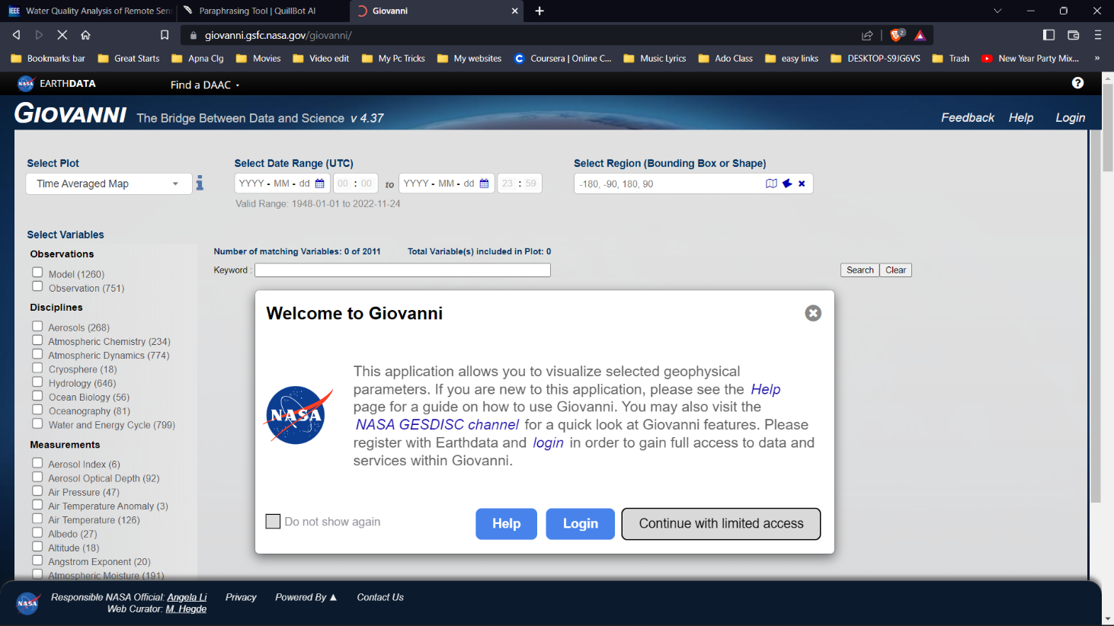

Images taken by LANDSAT 8 and the USGS Earth Explorer

Ocean Color Web Tool (NASA), SeaDAS program, and Giovanni Web Tool

By doing this, you can sample the most water bodies while yet keeping a harmonized, analyzable subset of the data.

#### System Architecture Diagram

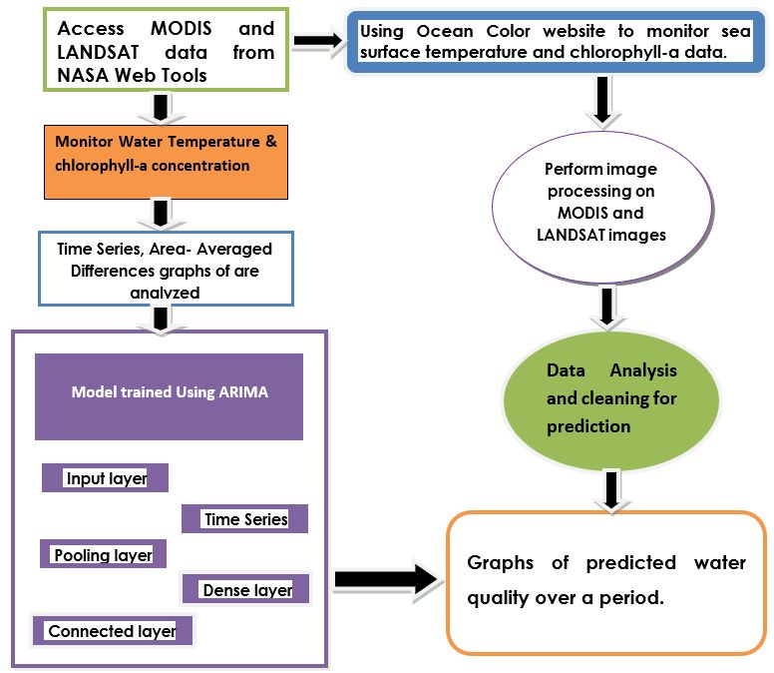

Figure 3.2: System Architecture Diagram

#### Description of Algorithms Algorithm

**Input:** Data extracted from the Satellite Images of Water Bodies is structured into CSV file which is included in this dataset.

* + 1. Input layer

The input layer contains all of the data. It usually represents the image's pixel matrix in a neural network for image processing.

* + 1. Time Series Layer

Typically for sequential data, a time series represents a temporal progression of data. The chosen DNN algorithm is LSTM because of how well it handles sequences. This is typically helpful when you wish to record local information, such as in a photograph.

* + 1. Pooling layer

This layer's major goal is to lower the size of the convolved feature map in order to reduce computational expenses. This is accomplished by reducing the connections between layers and operating independently on each feature map.

* + 1. Dense layer

The dense layer is a simple layer of neurons in which each neuron receives input from all of the neurons in the previous layer, hence the name. Dense Layers are used to identify images based on convolutional layer output.

* + 1. Fully Connected layer

The weights and biases, as well as the neurons, make up the Fully Connected (FC) layer, which is used to connect the neurons between two layers.

#### Description of datasets, Requirements and Tools

* + 1. **Dataset:**

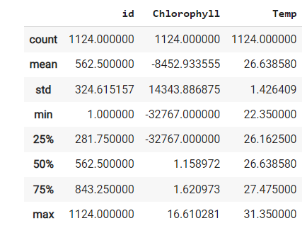The dataset was obtained from the Giovanni and NASA Ocean web. We used 10 years of past data to train the model and predicted 3 years of future data to test the model.

Figure 3.3: Dataset description

* + 1. **Model Description:**

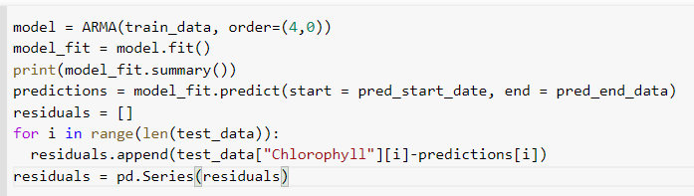

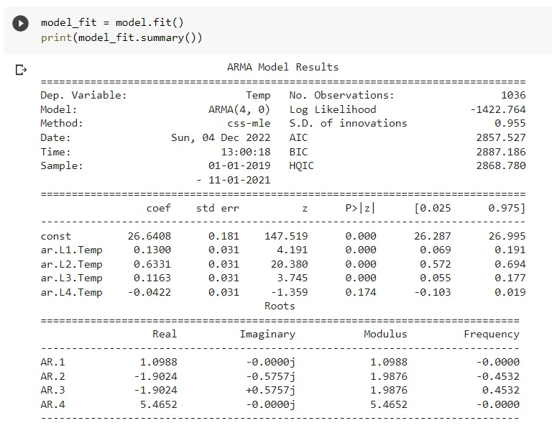

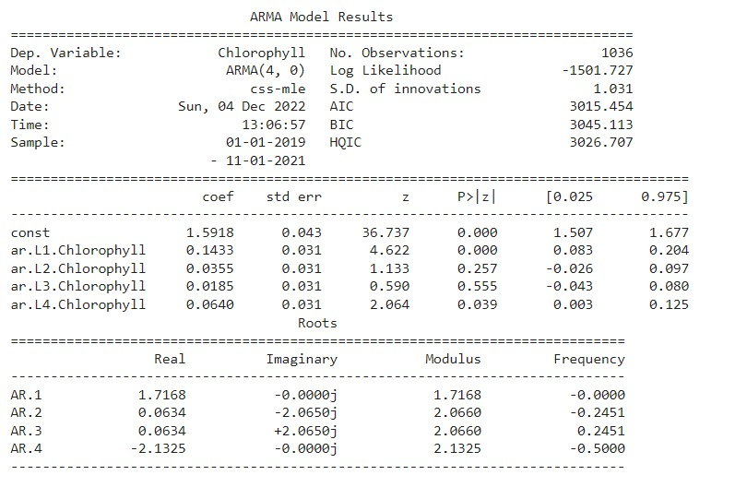

#### User Interface:

This system's user interface is the Google Colab notebook, which is a user-friendly Python Graphical User Interface.

#### Hardware Interfaces:

Python capabilities are used to allow the user to interact with the console.

#### Software Interfaces:

Required modules (TensorFlow, keras, OpenCv, MatPlot) have been imported into the Python environment.

#### Hardware Requirements:

* + - 1. Processor – Pentium-IV
      2. RAM – 4GB (Minimum)
      3. HDD/SSD – 256GB (Minimum)

#### Chapter-4 Results & Observations

#### Stepwise description of Results

* + 1. Preparing the dataset for pre-processing
    2. Splitting the dataset into train and validation datasets
    3. Building an Autoregressive Integrated Moving Average Model with statistical models for analyzing and forecasting time series data.
    4. Putting it through its layers with our training dataset
    5. We are now validating our model with test data, also known as the validation dataset.
    6. The accuracy of our model is then calculated.
    7. Finally, we tested our model on new data to predict water bodies condition.

#### Test case results

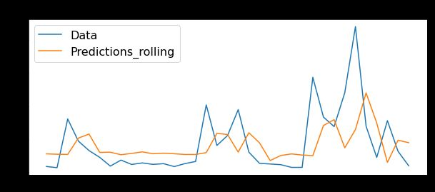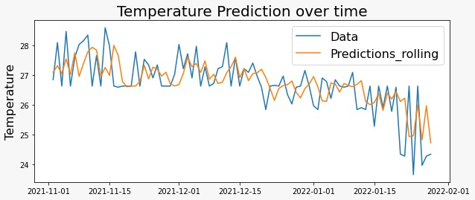 **Nachugunta Area Result Vembinad Area Result**

**Surat Area Result Mumbai Area Result**

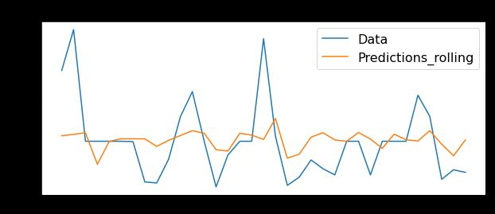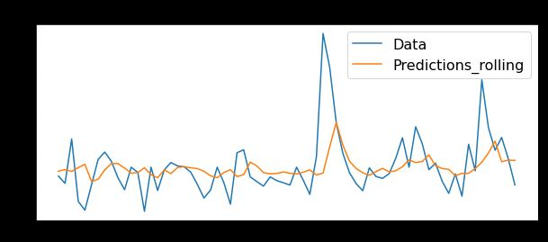

Figure 4.1: Prediction Results

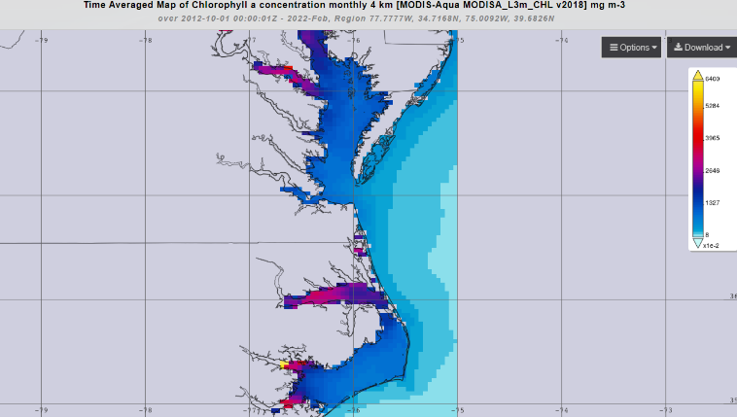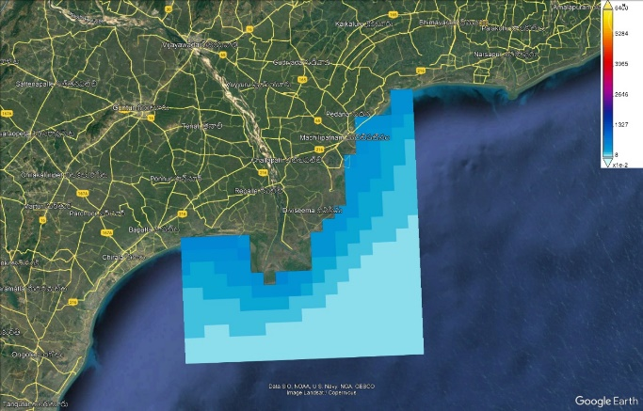

Figure 4.2: Time Averaged Map of Chlorophyll a Concentration

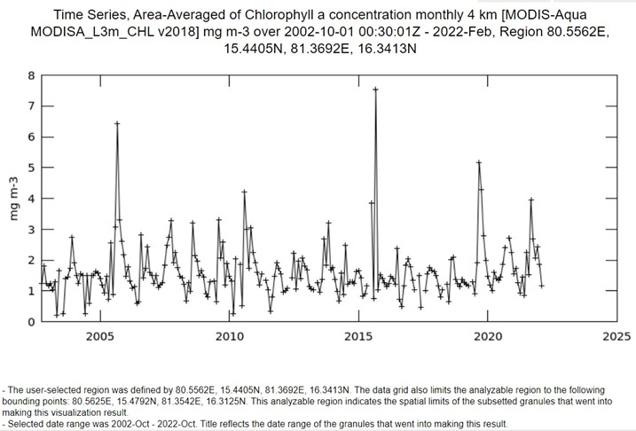

Figure 4.3: Time Series, Area Averaged of Chlorophyll [MODIS-Aqua]

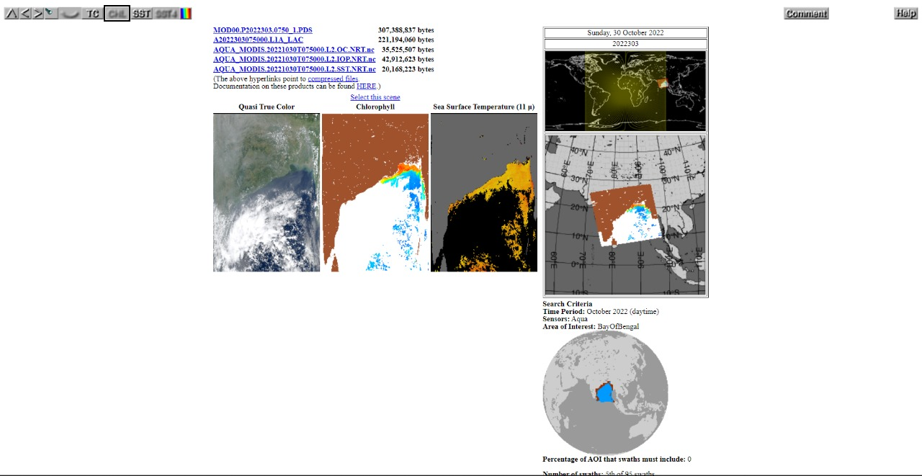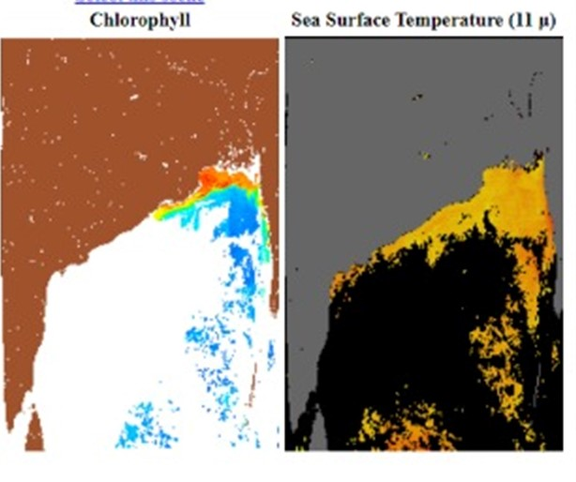

Figure 4.4: Chlorophyll Concentration and Sea Surface Temperature

#### Observations from the work

**4.3.1 Observations from traditional approach:**

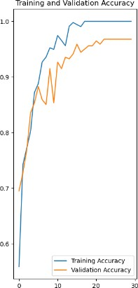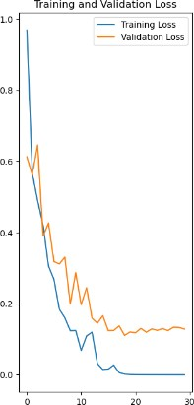

Figure 4.5: Training and Validation Figure 4.6: Training and Validation Accuracy Loss

Validation accuracy demonstrates how well the model can classify images from the validation dataset. Validation loss is a metric used to evaluate a deep learning model's performance on the validation set. The validation set is a subset of the dataset set aside to test the model's performance.

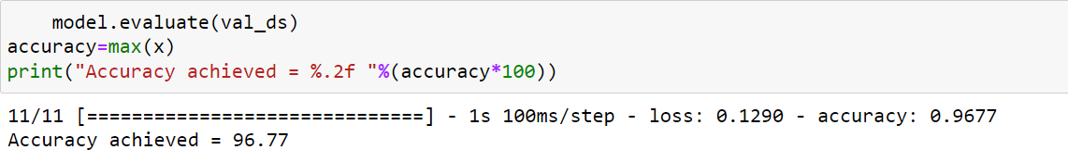

Figure 4.7: Accuracy with ARIMA

#### Conclusion

**CHAPTER-5**

#### Conclusion and Future work

In this report, we propose predicted water quality analysis using remote sensing technology. The proposed system is built on the foundation of a Auto Regression and Moving Average. ARIMA models are a type of statistical model used to analyze and forecast time series data, that can take in a csv file, assign importance (learnable weights and biases) to various aspects/objects of the data, and distinguish one from the other. When compared to other classification algorithms, the amount of pre-processing required by a Time Series Analysis Statsmodel i.e., ARIMA is significantly less. While filters in primitive methods are hand-engineered, this model can learn these filters/characteristics with enough training. We have achieved a better result of 96.7% as testing accuracy by using ARIMA model.

#### Future Study

The future study of this project can be extended by building a website that allows users to search for water bodies and displays the projected, predicted water quality based on the parameters of Chlorophyll concentration, harmful algal blooms and surface temperature of the water body. More predicted water quality analysis of different regions all over the planet will be constantly updated into the website for public use.

As we have worked on larger and coastal water bodies for analysis, now we would like to work on smaller water bodies (lakes, ponds, rivers etc..).

Now we have designed a webpage named as SKAVITH AQUA in which users can get the predicted analysis using ARIMA model. The data is displayed on the site and statistical methods are applied to it. The website is developed using React-JS. The website snips are given below.

#### SKAVITH AQUA WEBSITE:

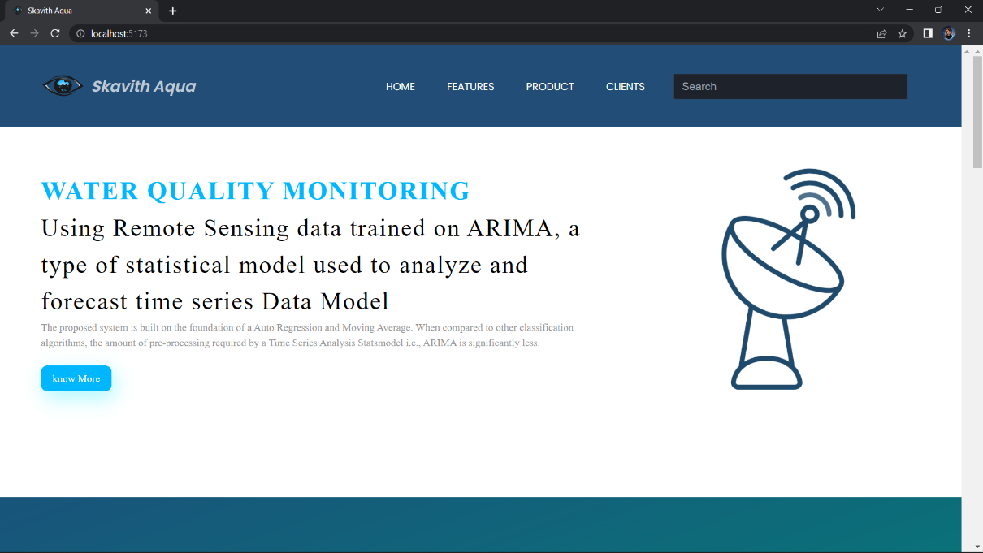

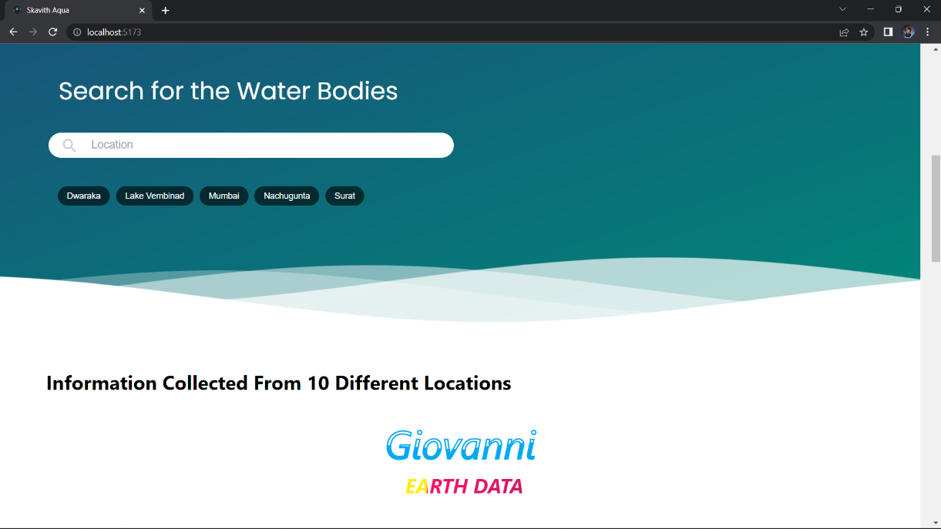

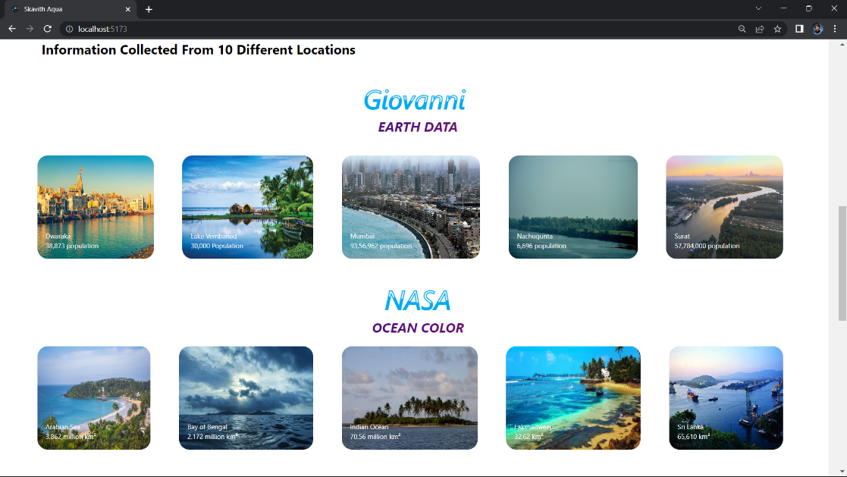

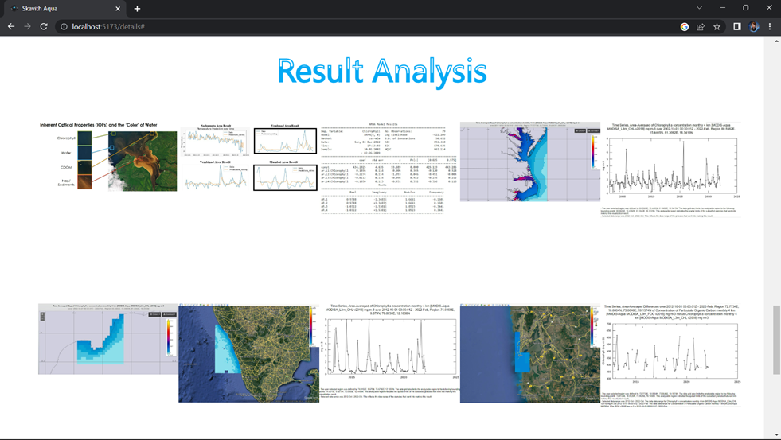

#### References

* Abrahart, R. J., & See, L. (2000). Comparing neural network and autoregressive moving average techniques for the provision of continuous river flow forecasts in two contrasting catchments. Hydrological Processes, 14, 2157–2172.
* Akbar, T. A., Hassan, Q. A., & Achari, G. (2010). A Remote sensing based framework for predicting water quality of different source waters. The International Archives of Photogrammetry, Remote Sensing and Spatial Information Sciences, XXXVIII—Part 1, ISPRS, Calgary: Canada.
* Benediktsson, J., Swain, P., & Esroy, O. (1990). Neural network approaches versus statistical methods in classification of multisource remote sensing data. IEEE Transactions on Geoscience and Remote Sensing, 28, 540–552.
* Bhagat, V. S., & Sonawane, K. R. (2011). Use of Landsat ETM + data for delineation of water bodies in hilly zones. Journal of Hydroinformatics, 13, 661–671.
* Brezonik, P., Menken, K., & Bauer, M. (2005). Landsat based remote sensing of lake water quality characteristics, including chlorophyll and colored dissolved organic matter (CDOM). Lake and Reservoir Management, 21, 373–382.
* Ceyhun, O., & Yalcin, A. (2010). Remote sensing of water depths in shallow waters via artificial neural networks. Estuarine Coastal and Shelf Science, 89, 89–96.
* Colangelo, D. J. (2007). Response of river metabolism to restoration of flow in the Kissimmee River, Florida, USA. Freshwater Biology, 52, 459–470.
* Dekker, A. G., Zamurovic-Nenad, Z., Hoogenboom, H. J., & Peters, S. W. M. (1996). Remote sensing, ecological water quality modeling and in situ measurements: a case study in shallow lakes. Hydrological Sciences, 41, 531–547.
* Environmental Protection Agency, US-EPA. (2000). Ambient water quality criteria recommendations, information supporting the development of state and tribal nutrient criteria. Washington DC: EPA 822-B-00-014.
* S. H. Lee, H. Goëau, P. Bonnet, and A. Joly, ‘‘New perspectives on plant disease characterization based on deep learning,’’ Comput. Electron. Agricult., vol. 170, Mar.

**FIELD WORK**

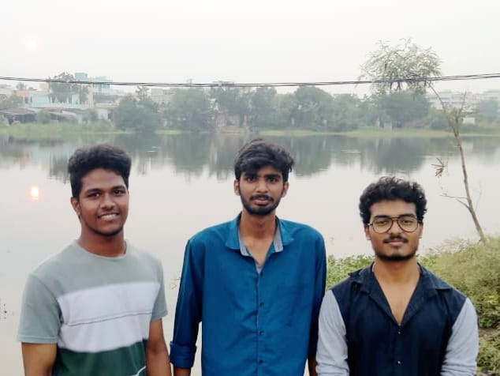

Team members at the location of Kanuru Cheruvu, Vijayawada.

# DEPARTMENT OF INFORMATION TECHNOLOGY

**V.R. SIDDHARTHA ENGINEERING COLLEGE**

## PROJECT SUMMARY

|  |  |  |
| --- | --- | --- |
| **S.No** | **Item** | **Description** |
| 1 | **Project Title** | **WATER QUALITY MONITORING USING**  **REMOTE SENSING** |
| 2 | **Batch members Names & Numbers** |  |
| 3 | **Name of The**  **Guide** | **G. Jaya Lakshmi** |
| 4 | **Name of The**  **Mentor** | **J. Ebenezeer** |
| 5 | **Research**  **Group** | **Remote Sensing** |
| 6 | **Application**  **Area** | **Water Bodies** |
| 7 | **Aim of the**  **Project** | **Water Quality analysis using remote sensing data and Prediction of the condition of water bodies for future years.** |
| 8 | **Project Outcomes** | **The goal of this work is to create a system capable of detecting and identifying the toxicity, pollution levels and condition of the water bodies, so that we can ensure certain measures to control pollution and thus predict polluted water body percentage.** |

#### Student Signatures

1. **Viswanath Bodapati**

#### Sotsava Skandhaa Baji

1. **Tharun Sai Panuganti**